COMPUTER SCIENCE DEPARTMENT
MILITARY COLLEGE OF SIGNALS, NUST
FUNDAMENTALS OF PROGRAMMING
BESE 16 A
Exam: Final lab exam Instructor: Shahela Saif
Type of Paper: Regular Total Marks: 30
Semester: Fall 2010 Time Allowed: 180 min

Note:
1. Use of course work slides or other helping material is not allowed.
2. Submit your work in the assignments folder as other regular assignments.
3. Copied submissions will be cancelled altogether.

Question .No.1 (10)

Write a program that takes an input from user and checks to see whether it is a palindrome or not. A palindrome is a string/value that reads the same in both directions e.g. racecar, level, 23432.
Create two functions, one for checking string values and the other for checking integer values for palindrome. Provide the user a menu to choose any one of the following.
Hint: Divide the input (string/number) into individual elements and match the first half with inverse of second half.

Sample Output:
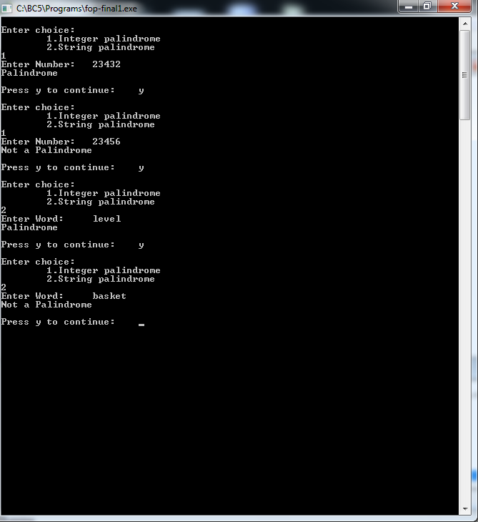

Question .No.2 (10)
Create a money converter. The user inputs a 7 digit number; break it down to individual tens, hundreds, thousands, and millions. Also, if individual amounts are entered, it should be able to display it in a collective form.
Note: The second part requires only a collective display in the given format, not an actual addition of values.

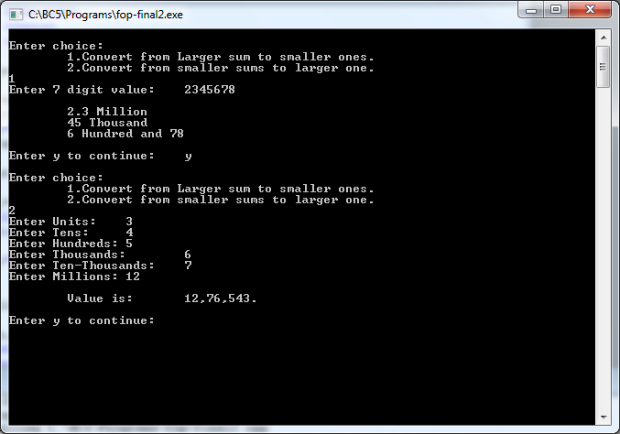

Question .No.3 (10)
Write a program that performs basic arithmetic on polynomial expressions. A polynomial expression has the form ax² + bx + c, where a,b and c are coefficients and x is a variable. Create a structure to hold coefficients of a polynomial expression. The program should be able to:
- Add two polynomial expressions
- Subtract two polynomial expressions
- Solve a polynomial expression for given value of x.
Hint: the addition and subtract involves only the addition and subtraction of corresponding coefficients of the two polynomials. Part c requires multiplication of values of coefficients with appropriate value of x.
